Web Development

ASSESSMENT 2: Web Development Project

| Contribution towards overall module mark | 60% |
| --- | --- |
| Date set | March 27, 2024 |
| Marked work returned by | June 20, 2024 |
| DEADLINES | Deadline: May 31, 2024 - 11:59PM |

**Assessment 2: Web Development Project**

|  |  |
| --- | --- |
| **Students Name** | Cyla Rica Bautista |
| **Roll No** | 2023747 |
| **Github Repository Name** | Rylelinn |
| **Github Repository Link** | https://github.com/IntroToProgramming-CCL4/assessments-Rylelinnn/tree/f877b1d14a0407b0d9e314baa028510c1fbcf317/Semester%202%20final%20Asses%202 |
| **Repository Screen Shot** |  |
| **Theme (Topic)** | My Own School  Develop an eco-friendly university website showcasing sustainability initiatives, academic programs, admissions information, and campus life |

● Brief:

When creating a website for Eduford, a school committed to promoting eco-friendly sustainability, our main attention was on five essential pages: home, about us, course, blogs, and contact. The top of the website has the university logo and a detailed navigation menu. The main banner displays high-quality photographs of the campus along with the tagline 'Leading the Way in Sustainable Education.' There are also buttons that encourage visitors to either 'Visit Us To Know More' or 'Learn More.' In addition, the welcome section features a greeting from the university and a concise introduction that emphasizes Eduford's dedication to sustainability.

● Design Direction:

I used earthy colors and a clean, modern look to make the Eduford website fit with the school's promise to be Sustainable and Eco friendly . The main idea behind the design is to give people a creative and modern way to learn while still letting them feel at ease with nature. The website shows high-resolution school photos, a compelling slogan, and prominently displayed hover styled "call to action" buttons in order to captivate users. Furthermore, it demonstrates Eduford's aspiration to become a frontrunner in the realm of eco-conscious education. The page contains these components.

The color palette, typography, and artistic elements are intentionally designed to evoke a sense of tranquility and foster a strong sense of connection with one's environment. We will create an online platform that is welcoming and motivating for parents, stakeholders, prospective students, and our colleagues. This design focuses on keeping things simple and easy to navigate so that guests can quickly look at the information about classes, admissions, and college life.

Look at this picture of the homepage:

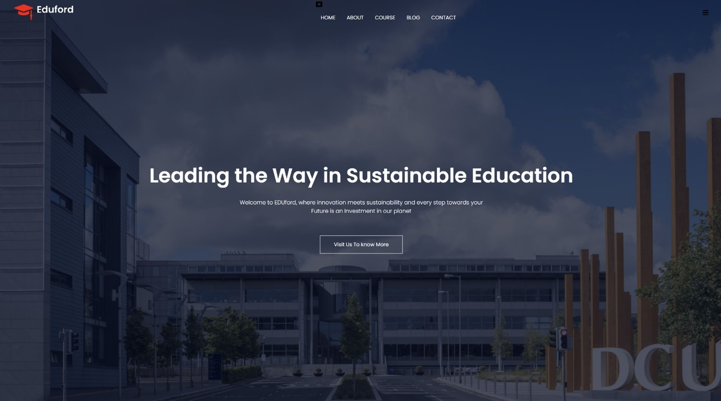

The website's design style is meant to show Eduford's ideas about creation, sustainability, and communities that are good for the environment furthermore this is made by giving users the chance to look into and learn more about different educational programs that are saved in a digital platform that looks good and is easy to use.

● Interaction Overview:

The Eduford website is designed to be easy for users to navigate and use, with control buttons that look like they're scrolling over things and clicking action to icon changes. Key pages like "home," "about us," "courses," "reviews," "campus life," "blogs," and "contact" are all easy to get to from the navigation menu.

By clicking on the buttons on the website, they can easily do simple things like applying for entry, setting up a visit by phone or social media, or getting more information about their efforts to promote sustainability. The navigation bar, our classes, and clickable banners are all interactive parts that keep visitors excited and make it easier for them to find information.

Users of the website may browse its content at their own speed. The photos and brief details on the website will assist learners to grasp Eduford's dedication to environmentally friendly learning. Thanks to responsive design, which guarantees that it performs effectively on all of them, users may readily access the website from desktop computers, laptops, tablets, and smartphones.

● Technical Description:

There is a basic HTML framework with some JavaScript features and CSS styling in the code which was given. Here's how all the technical parts are broken down:

1. Structure of HTML:

* The `<head>` section contains meta tags, titles, and links to external files for Fonts from font awesome , Icons from font awesome, CSS, link CDN in font awesome and JavaScript. These are the elements are provided for users convenience.
* The search bar, the navigation menu, and the logo are all located in the title section of the website.
* the <<ul>` tag, is utilized to build the navigation menu.
* This is the main banner, which is a huge banner that includes a tagline and buttons that allow users to take action. Button has a pop up color design when curor pointer points at it
* Displays Eduford's course offerings in three columns by utilizing `<div>` elements with the class `course-col`. - The Courses Section displays the courses, degree and under graduate courses with sentences below it.
* A section provides information about Eduford's campuses located in 3 parts of the world, along with images and titles that correspond to each site with transition effect of 0.5.
* The amenities Section provides a great overview of the different amenities available at Eduford, including the library, gymnasium, and cafeteria, along with images and explanations of how sustainable and friendly each facility.
* Included in the "Testimonials Section" are student testimonies that include images, comments, and star ratings, all Icons of which are created with Font Awesome.
* A button that links to the contact page is included in the "Call to Action" section, which encourages people to sign up for online classes.
* The footer section includes information about Eduford, symbols for socialmedia, and credit information for the me.

2. JavaScript Functionality

* JavaScript functions is used in order to manage the display of the navigation menu, which enables it to glide in and out whenever the menu icon is clicked.

3. CSS contains

* Universal font Styles: this is Google fonts 'Poppins' font family to all elements.
* Header Section
* Navigation Menu.
* Main Banner: Styles for the main banner and Hover effect changes the button background color.
* Responsive Design: Media queries are used to adjust styles for smaller screens (max-width: 700px). – for Phones
* Course Section: Styles for the courses and column layout, and box shadow on hover.
* Campus Section: Styles for the campus and and hover effect for the overlay layer.
* Facilities Section: Styles for the facilities and including image sizing, border radius, and text alignment.
* Testimonials Section: Styles for the testimonials and The hover effect changes the background color.
* Footer Section: Styles for the footer section, and social media icons.

● Critical Reflection

I need to add more details and style aspects to the Eduford website so that it's even better for everyone. By fully looking at classes, campus life and facilities, and efforts to be more eco-friendly can teach users a lot. They can use these tips to find the best school for them.

Having more than one media function, like videos, can make the experience more fun and useful for the user. Some things that can help people who want to go are introductory videos that show how life is on campus, interviews with teachers and students, and virtual tours of the facilities. These movies can show that Eduford cares about the environment and get the word out about its green grounds and programs.

Adding quizzes, polls, and interactive maps is another way to get more people to link and participate. People can learn new things and have fun at the same time, like with quizzes about sustainability or college trivia. Users can use interactive maps(Virtualy) to move around campus and see all of its services and buildings.These videos can demonstrate Eduford's environmental consciousness and help to spread knowledge of its green policies and grounds.

Including interactive maps, polls, and quizzes will help to increase link and participation among others. Like with poll quizzes on sustainability or college trivia, people can have fun and pick new skills at the same time this will engage them more to visit my website. Virtualy's interactive maps would help and let users navigate campus and view all of its buildings and services.

New design trends like graphics, and micro-interactions can make the website look better and keep people interestedin in th website. I added Hover effects, scrolling changes, and loading animations can all be made more lively and polished, by adding more small animations this will make my website engaging.

It can be easier for people to use and share information if the app works well with social media sites.

Getting better at web development is needed to make these changes for me to grow more I need to learn mpre skills like example, you should learn how to use motion tools (like GSAP) and link social media APIs. I can also learn how to edit videos using applications like Adobe Premiere Pro or After Effects so that I create interesting videos for my website.

The Eduford website can make the experience more engaging, interesting, and easy to use by adding more details, style elements, and multimedia material. This will make users happier and more loyal in the long run.